Welcome!
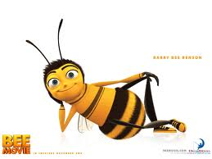
You need your Literature book!

Romantics
Warm Up #1

Think about the ways in which you react to different aspects of nature, such as a rainy day, the first signs of spring, or a beautiful sunset. Explain a reaction that you’ve had.
Why are people affected by nature in different ways?

Do you think nature can affect the way a person thinks, feels, or acts? Please explain.

Warm Up #2

Think of someone in your family, school, or community who conveys strong emotions when speaking. Please describe him/her.

Do you think the ability to express powerful emotions is an advantage or disadvantage?
Please explain your thoughts.

Warm Up #3

Please do the Personal Connection on p. 597.

For each pair of opposite qualities, draw the scale and mark where you think your romantic personality falls. Please give a brief explanation for each.

Warm Up #4
In your opinion, what are the most important elements of a successful marriage?
Name and explain at least three.

Warm Up #5

Respond to the following quote by Oscar Wilde:
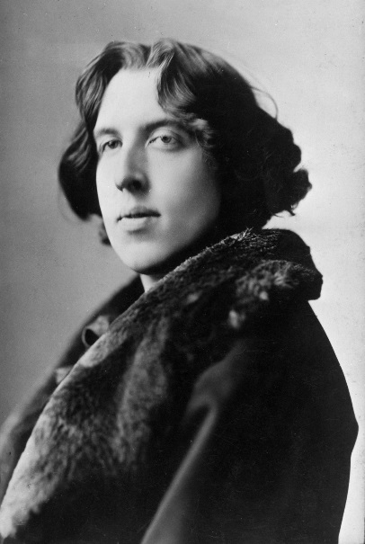
“In this world there are only two tragedies. One is not getting what one wants, and the other is getting it.”

What is meant by this quote? Explain.

Warm Up #6

“I am not young enough to know everything.” ~ Oscar Wilde

Do the young think they know everything? Why or why not?
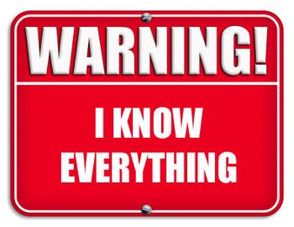

Warm Up #7
A comedy is a light dramatic work that is often humorous in tone. It aims chiefly to amuse. It usually has a happy ending.
- Comedy is often classified as high or low, although both forms can occur in the same work.
  - High comedy is subtle, appeals to the intellect, and achieves a thoughtful, often satirical humor.
  - Low comedy is crude and has little intellectual appeal.

A farce is a lighthearted comedy that centers around a ridiculous plot that usually involves exaggerated and improbable events.
  - Farces usually do not have much character development, but instead rely on absurdity, physical humor, and a skillful exploitation of a situation.

Do you believe “The Importance of Being Earnest” falls under the category of comedy (high or low) or farce? Please give 2-3 reasons to support your opinion.

Warm Up #8

What do you think will happen in Act II regarding Algernon and his interest with Cecily Cardew?

Will Jack/Ernest confess to Gwendolen about his secret identity?

Warm Up #9

Oscar Wilde originally gave this play the subtitle A Trivial Comedy for Serious People.
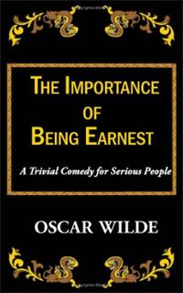
What do you think he meant by this description of the play?

of little value or importance
(of a person) concerned only with trifling or unimportant things.

Warm Up #10
Free Write

Warm Up #11

What is your opinion of the end of the play?

Were you surprised?

Did you predict anything to happen?

How does the title fit in to the conclusion?

Warm Up #12

Think of writers and entertainers who use humor to call attention to the faults of society or government.

Do you think that their humor can lead to reform and change? Explain your reasoning.

Write down your thoughts about humor and its potential for bringing changes in society.

Warm Up #3

What is your reaction to the “You’re Welcome” segment from The Daily Show?

Are the proposals realistic?

Is the satire effective?

Please explain your thoughts.

Warm Up #14

Describe your reaction to Jonathan Swift’s proposal.

What is Swift proposing the people of Ireland do?
Make some predictions of how he will defend this proposal.

Warm Up #13

In the 17th and 18th centuries, the only females who received an education were those whose families could afford private lessons, and even then, they were taught only a few subjects and were barred from attending universities.

On the basis of your understanding of history and social customs, why do you think females were prevented from receiving the same education as males?

Explain your thoughts on this subject.

Warm Up #15
Free Write

