Predicting
The Johnstown Flood (102-108) and Magazine Article (111) TttT

As you read, keep track of the thoughts you have in connection with the story.
You must use at least 4 different strategies and record a quote.
Record your thoughts in the space below. Continue your TttT on the back if you need more space.
Label each item with a corresponding page number.
Complete the questions and mood activity.

Name:
I predict that…
In the next part, I think…
I think this is going to happen…

Picturing
I can picture…
I can see…
I imagine…

Questioning
A question I have is…
I wonder about…
Could this mean…
Why is…

Making Connections
This is like…
This reminds me of…
I had an experience…

Identifying a problem
I’m confused about…
I’m not sure of…
I do not understand…

Summarizing
It is saying…
The big idea here is…
I think the point is…

Reaction
I did not expect…
I was mad/happy/excited about…
I wish…

Using fix-ups
I’ll reread this…
I’ll look up… (words you cannot define)
I will ask…

Write down a quote
that you thought
was important,
memorable, or
powerful.

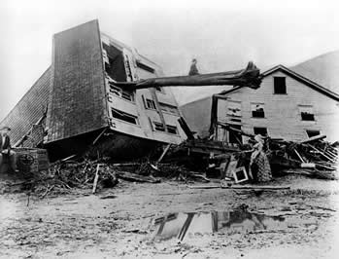
TttT continued

Questions
- Identify Cause and Effect: What most accounts for Gertrude’s miraculous survival—sheer luck, Gertrude’s own actions, or others’ actions? Explain and quote at least two passages as support from the narrative.

- Critical Interpretation: David McCullogh has said that in his writing he tries to make history “as interesting and human as it really was.” Do you think he succeeds in doing so in the selection from The Johnstown Flood? Explain and support your opinion by quoting at least two examples from the narrative.

Mood
Mood is the feeling or atmosphere that the writer creates for the reader. In The Johnstown Flood, which is an historical narrative, the author manages to create a mood of tension by using descriptive words and phrases, details of setting, and imager.
In the chart below, record descriptions, details, and imagery that best work to create a mood of tension or impending doom. One has been done as an example.
Please include at least TWO EXAMPLES for each aspect.
- Descriptive words and phrases | - “restless and worried” (line 8)
- Details of setting
- Imagery

