**Thought Starter #1**

Please respond to one of the following quotes about friendship. You may react with personal stories/experiences or general opinions.

[](http://images.search.yahoo.com/images/view;_ylt=A0PDoS9_4YdRRF4A7bCJzbkF;_ylu=X3oDMTBlMTQ4cGxyBHNlYwNzcgRzbGsDaW1n?back=http://images.search.yahoo.com/search/images?_adv_prop=image&va=quotes+about+friendship&fr=yfp-t-900&tab=organic&ri=2&w=450&h=400&imgurl=todaynewz.com/wp-content/uploads/2012/07/friendship-quotes-2012.gif&rurl=http://todaynewz.com/friendship-day-2012-sms-quotes-messages/&size=54.1KB&name=%3cb%3efriendship+quotes+%3c/b%3e2012+%3cb%3eFriendship+%3c/b%3eDay+2012+SMS+%3cb%3eQuotes+%3c/b%3eMessages&p=quotes+about+friendship&oid=6ff1cca14912ca98a23def5a5f7ba5eb&fr2=&fr=yfp-t-900&tt=%3cb%3efriendship+quotes+%3c/b%3e2012+%3cb%3eFriendship+%3c/b%3eDay+2012+SMS+%3cb%3eQuotes+%3c/b%3eMessages&b=0&ni=66&no=2&ts=&tab=organic&sigr=11t92dl06&sigb=13lpav9di&sigi=123q9l89g&.crumb=HVInWG1Qk3p&fr=yfp-t-900)[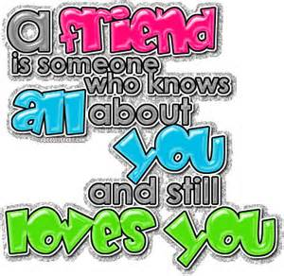](http://images.search.yahoo.com/images/view;_ylt=A0PDoS9_4YdRRF4A8bCJzbkF;_ylu=X3oDMTBlMTQ4cGxyBHNlYwNzcgRzbGsDaW1n?back=http://images.search.yahoo.com/search/images?_adv_prop=image&va=quotes+about+friendship&fr=yfp-t-900&tab=organic&ri=6&w=383&h=373&imgurl=2.bp.blogspot.com/-Q1zeUjIuokA/TYMkPWOzUeI/AAAAAAAAAEw/yLHBQHQQ4BI/s1600/FF.gif&rurl=http://chiragfrnds.blogspot.com/2011/06/friendship-quotes.html&size=66.7KB&name=Friends+4ever...!:+%3cb%3efriendship+quotes%3c/b%3e&p=quotes+about+friendship&oid=f06401b0a5dd27f9ecc0c204b2229e85&fr2=&fr=yfp-t-900&tt=Friends+4ever...!:+%3cb%3efriendship+quotes%3c/b%3e&b=0&ni=66&no=6&ts=&tab=organic&sigr=11u515h5r&sigb=13lmsf6o6&sigi=12fmqhn8i&.crumb=HVInWG1Qk3p&fr=yfp-t-900)[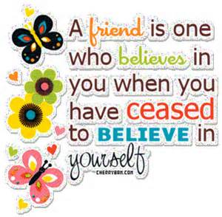](http://images.search.yahoo.com/images/view;_ylt=A0PDoS9_4YdRRF4AB7GJzbkF;_ylu=X3oDMTBlMTQ4cGxyBHNlYwNzcgRzbGsDaW1n?back=http://images.search.yahoo.com/search/images?_adv_prop=image&va=quotes+about+friendship&fr=yfp-t-900&tab=organic&ri=28&w=301&h=295&imgurl=3.bp.blogspot.com/-OUvenvmpSfE/TWQSs1ywttI/AAAAAAAACRw/nhT050KpGdU/s400/friendship_quotes.gif&rurl=http://www.66quotes.org/2011/02/friendship-quotes.html&size=80.5KB&name=%3cb%3eFriendship+Quotes+%3c/b%3e|+%22Motivational+and+Inspirational+%3cb%3eQuotes%3c/b%3e%22&p=quotes+about+friendship&oid=e7867eb16ae8b4093fdc7434573188e5&fr2=&fr=yfp-t-900&tt=%3cb%3eFriendship+Quotes+%3c/b%3e|+%22Motivational+and+Inspirational+%3cb%3eQuotes%3c/b%3e%22&b=0&ni=66&no=28&ts=&tab=organic&sigr=11m90luq7&sigb=13m5m803g&sigi=12t5frv16&.crumb=HVInWG1Qk3p&fr=yfp-t-900)[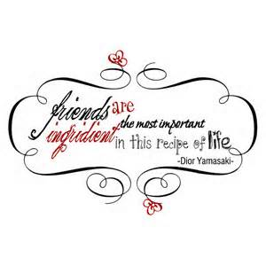](http://images.search.yahoo.com/images/view;_ylt=A0PDoS9_4YdRRF4A.bCJzbkF;_ylu=X3oDMTBlMTQ4cGxyBHNlYwNzcgRzbGsDaW1n?back=http://images.search.yahoo.com/search/images?_adv_prop=image&va=quotes+about+friendship&fr=yfp-t-900&tab=organic&ri=14&w=600&h=600&imgurl=2.bp.blogspot.com/-mr9GNU_AoCA/T3x4JG0Oz1I/AAAAAAAAAFA/VL0KWWCIT2U/s1600/friendship_quotes1_e.jpg&rurl=http://friendshipisthebestmedicine.blogspot.com/2012/04/friends-forever-quotes.html&size=98.6KB&name=%3cb%3eFRIENDSHIP+%3c/b%3eIS+THE+BEST+MEDICINE:+Friends+forever+%3cb%3equotes%3c/b%3e&p=quotes+about+friendship&oid=b5d79350ae05c9f4684787394ec3da07&fr2=&fr=yfp-t-900&tt=%3cb%3eFRIENDSHIP+%3c/b%3eIS+THE+BEST+MEDICINE:+Friends+forever+%3cb%3equotes%3c/b%3e&b=0&ni=66&no=14&ts=&tab=organic&sigr=12jlh7pak&sigb=13mhiat76&sigi=131fjbsah&.crumb=HVInWG1Qk3p&fr=yfp-t-900)[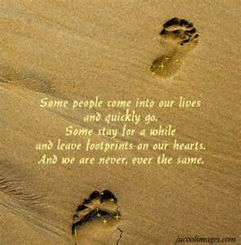](http://images.search.yahoo.com/images/view;_ylt=A0PDoTFG4odRLEkAm5qJzbkF;_ylu=X3oDMTBlMTQ4cGxyBHNlYwNzcgRzbGsDaW1n?back=http://images.search.yahoo.com/search/images?p=quotes+about+friendship&_adv_prop=image&va=quotes+about+friendship&fr=yfp-t-900&tab=organic&ri=39&w=375&h=379&imgurl=welovestyles.com/wp-content/uploads/2012/02/wallpapers-of-quotes-on-friendship-4.gif&rurl=http://www.welovestyles.com/friendship-quotes/&size=123.6KB&name=%3cb%3eFriendship+Quotes+%3c/b%3e(1)&p=quotes+about+friendship&oid=4d8d274021f96e1ddb657fa888de4474&fr2=&fr=yfp-t-900&tt=%3cb%3eFriendship+Quotes+%3c/b%3e(1)&b=31&ni=48&no=39&ts=&tab=organic&sigr=11ep7e2be&sigb=14gosnhgo&sigi=12kqu7bsm&.crumb=HVInWG1Qk3p&fr=yfp-t-900) [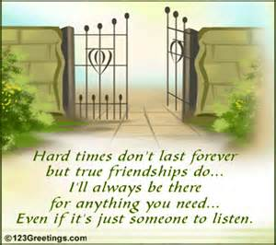](http://images.search.yahoo.com/images/view;_ylt=A0PDoS9_4YdRRF4A_LCJzbkF;_ylu=X3oDMTBlMTQ4cGxyBHNlYwNzcgRzbGsDaW1n?back=http://images.search.yahoo.com/search/images?_adv_prop=image&va=quotes+about+friendship&fr=yfp-t-900&tab=organic&ri=17&w=450&h=400&imgurl=1.bp.blogspot.com/-5r_vwkfJ0KM/TezzMoSakdI/AAAAAAAAA3E/b-CRrihNJAE/s1600/friendship_quotes.gif&rurl=http://www.zimbio.com/Friendship+Quotes/articles/L3wxbUIziAF/broken+friendship+quotes+sayings&size=67.4KB&name=broken+%3cb%3efriendship+quotes+%3c/b%3eand+sayings+-+%3cb%3eFriendship+Quotes+%3c/b%3e-+Zimbio&p=quotes+about+friendship&oid=c071be73018fdfd167c2811bd60a7db0&fr2=&fr=yfp-t-900&tt=broken+%3cb%3efriendship+quotes+%3c/b%3eand+sayings+-+%3cb%3eFriendship+Quotes+%3c/b%3e-+Zimbio&b=0&ni=66&no=17&ts=&tab=organic&sigr=12t1c48as&sigb=13mi31cre&sigi=12u5k6ara&.crumb=HVInWG1Qk3p&fr=yfp-t-900)

**Thought Starter #2**

Please respond to the following quote using personal examples, ideas, and/or opinions.

**“Peace is achieved one person at a time, through a series of friendships.”**

--Fatma Reda

[](http://www.google.com/url?sa=i&rct=j&q=&esrc=s&frm=1&source=images&cd=&cad=rja&docid=GYBT4Yn_Jk_k0M&tbnid=m1kwTtDTdU0PiM:&ved=0CAUQjRw&url=http://hashtagpeace.tumblr.com/&ei=DOiIUbyoK8LIyAH_iIHgAw&bvm=bv.45960087,d.aWc&psig=AFQjCNGbZEclOLpsh1_MuH_uL_XSvvVksg&ust=1368013183770318)

What do you think this quote means? Do you agree? Disagree?

**Thought Starter #3**

Agree or disagree with Gene’s observation that “sarcasm [is] the protest of people who are weak.” (page 29)

[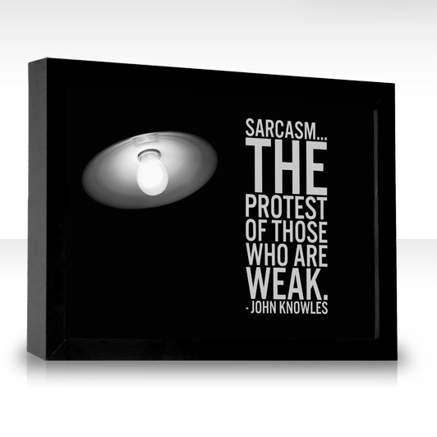](http://www.google.com/url?sa=i&rct=j&q=&esrc=s&frm=1&source=images&cd=&cad=rja&docid=pa0QRodkQcRySM&tbnid=lBUn9p0Um2O0lM:&ved=0CAUQjRw&url=http://www.thequotefactory.com/quote-by/john-knowles/sarcasm-the-protest-of-those/78038&ei=semIUd7_IYqwygHgroHICQ&bvm=bv.45960087,d.aWc&psig=AFQjCNFDijnmRrS_WMJh6cpsMsnf8on2_A&ust=1368013607523451)

If you agree, explain. If you disagree, explain your view of sarcasm.

**Thought Starter #4**

Please respond to both questions below.

[](http://www.google.com/url?sa=i&rct=j&q=&esrc=s&frm=1&source=images&cd=&cad=rja&docid=oEBz1EZH7_p7KM&tbnid=jRBMyB_QeDGnOM:&ved=0CAUQjRw&url=http://www.proginosko.com/2013/01/the-most-important-question/&ei=JeuIUfGPGYm9yAGezIHQBA&bvm=bv.45960087,d.aWc&psig=AFQjCNHdj2geAVjLL-oYIfdks6BT9JN-QQ&ust=1368013971869220)

1. What question do you think is important to ask about the story so far?
2. How is student life (and the school) at Devon similar and/or different from life at your school? Explain and support with details.

**Thought Starter #5**

**The author describes Chet as “weakened by the very genuineness of his interest in learning.” (p. 54)**

1. **Is there a difference between learning for the sake of learning and just doing what it takes to achieve top grades?**
2. **In the long run, which type of student do you think comes closest to meeting the true goals of education?**

**Support/Explain your opinion.**



**Journal #5(b)**

Create Finny AND Gene’s most recent report cards. Be sure to include subjects, letter grades, and teacher comments. Include a section on citizenship/behavior. (p.53)

**Class Grade Citizenship/Behavior Comments**

**Thought Starter #6**

Imagine that you are Finny. Write a letter to Gene after his visit and confession. Express your feelings about the situation.

[](http://www.google.com/url?sa=i&rct=j&q=&esrc=s&frm=1&source=images&cd=&cad=rja&docid=R8FCKyZugPuifM&tbnid=MgBVmV3kLBIXbM:&ved=0CAUQjRw&url=http://rothamelbratton.com/featured/how-to-write-a-letter-of-instruction-for-your-heirs/&ei=WwORUav_FqqoyAHw2YFY&bvm=bv.46340616,d.aWc&psig=AFQjCNG7MRq6EBxEdlhJbYEG-NqzvRxybg&ust=1368544418695585)

**Thought Starter #7**

On p.81-82, Mr. Ludsbury stops Gene and berates him (chews him out/scolds him).

[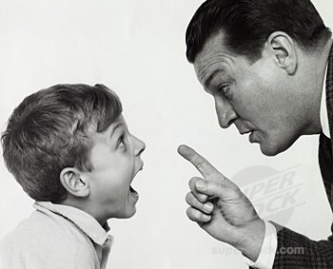](http://www.google.com/url?sa=i&rct=j&q=&esrc=s&frm=1&source=images&cd=&cad=rja&docid=Ti4Cd7gsxgszfM&tbnid=8Pm6fCquzhGvOM:&ved=0CAUQjRw&url=http://nickyrants2.blogspot.com/2010/03/kids-these-days.html&ei=Oe2IUdPoLLHeyQG83IDICw&bvm=bv.45960087,d.aWc&psig=AFQjCNGAfjdAD3eO32IhKi35ioy_HEhd9g&ust=1368014410683381)

Write an interior monologue for Gene that shows how he responds silently to each of Ludsbury’s remarks.

**Thought Starter #8**

**Free Write**

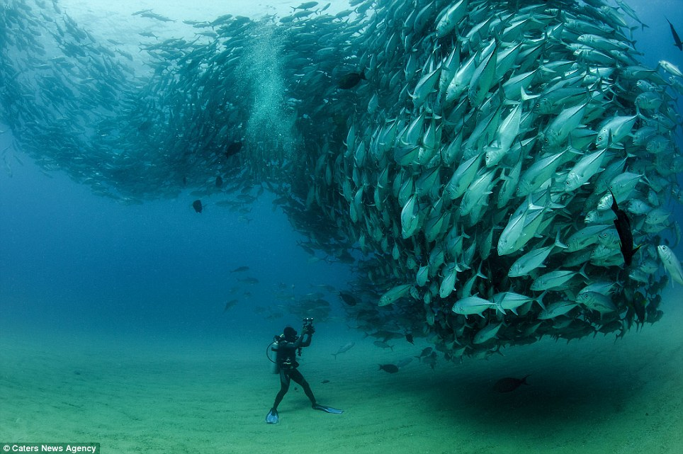

The faculty at Devon adopted an “Emergency Usefulness Policy” to help with the war (page 93).

Write what you believe would be stated in that policy. What would it say?

Would there be requirements for the students to help with the war effort?

[](http://www.google.com/url?sa=i&rct=j&q=&esrc=s&frm=1&source=images&cd=&cad=rja&docid=8qpe5hkZVO_guM&tbnid=WlYjZqbICP_WBM:&ved=0CAUQjRw&url=http://laveti.wordpress.com/tag/policy/&ei=hZuSUaOIDsjBygHCuYG4CQ&bvm=bv.46471029,d.aWc&psig=AFQjCNEYWmCCutSDkijYVaXtr8DLghnidQ&ust=1368648944829520)

**Thought Starter #9**

**Make a prediction**: How will the war eventually affect the boys? Will Finny admit that there is a war? Who will enlist first? Explain.

C:\Documents and Settings\jharding\Local Settings\Temporary Internet Files\Content.IE5\M5T1SDKR\MC900036522[1].wmf

**Thought Starter #10**

How does Brinker change after the morning Gene decides not to enlist? How do you explain these changes? (p. 129-130)

[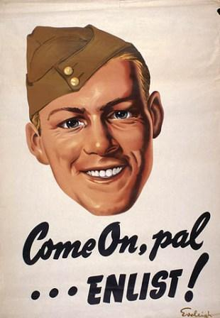](http://www.google.com/url?sa=i&rct=j&q=&esrc=s&frm=1&source=images&cd=&cad=rja&docid=ARYLw_-QWGusLM&tbnid=Ir8HRo54fSrXqM:&ved=0CAUQjRw&url=http://suboxforum.com/viewtopic.php?t=883&ei=c-2IUbjoBIWzywGm7IGQAw&bvm=bv.45960087,d.aWc&psig=AFQjCNFoJFiI1RcCIuYqhnU6bxtS8MVGVQ&ust=1368014568363089)

**Thought Starter #11**

Please respond to **one** of the following options:

* + 1. As Leper’s drill sergeant, write the official report on Leper, describing his period of service and the reason for his discharge.
    2. You are Leper’s mother. Write a letter to your sister about your son. Explain some of your worries about him and mention the visit by one of your son’s friends.

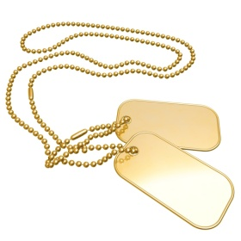

**Thought Starter # 12**

Gene has suffered a great deal of guilt since he caused Finny to fall from the tree.

[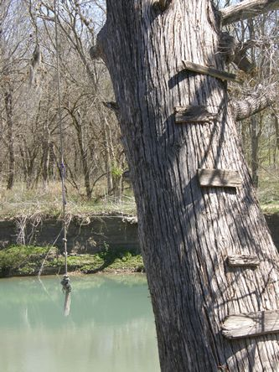](http://www.google.com/url?sa=i&rct=j&q=&esrc=s&frm=1&source=images&cd=&cad=rja&docid=kA_XHO0hsgsZOM&tbnid=-mQ5qvqfvUGFEM:&ved=0CAUQjRw&url=http://www.texasescapes.com/CentralTexasTownsSouth/Fentress-Texas.htm&ei=iO-IUYfaO8TAyAH7n4DYDw&bvm=bv.45960087,d.aWc&psig=AFQjCNERXJOtVh-N1I9A-B3hU5IoiOgUMg&ust=1368015047733176)

Who is to blame for this second accident?

Was Brinker overstepping boundaries he should not have crossed? Was Leper?

**Thought Starter #13**

What is your reaction to Finny’s death?

**Prediction:** Will the others blame Gene for Finny’s death?

Do you blame Gene? Explain.



**Thought Starter #14**

What is your impression of the novel?

[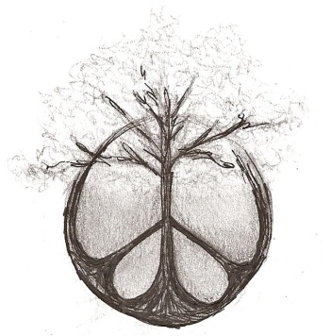](http://www.myspace.com/kenny.kane)

What did you like about it? What didn’t you like about it?

Why do you think John Knowles chose this title?

Please also choose a quote that sticks in your mind and explain it.