**Onomatopoeia** is a word or a grouping of words that imitates the sound it is describing, suggesting its source object, such as "click," "clang," "buzz," or animal noises such as "oink", "quack", "flap", "slurp", or "meow".   
  
Criteria for drafting the Onomatopoeia Poems is:

***1.*** *Poem's length: 1 stanza of no less than four lines--a minimum of three words per line.****2.*** *Rhyme scheme: ABCB (and every even numbered line should rhyme if a single stanza is longer than four lines).****3.*** *Lines 1 and 3 (and odd lines if more than four lines) should contain* onomatopoeia.***4.*** *Punctuate and title your poems.****5.*** *Have fun with your word choice!*

Here are two student examples:

***Bad Leak*** *Drip, drip, drip.  
 The faucet had a leak!  
Slop, drop, plop.  
The rushing water formed a creek.*

Only **ONE** line with the same/repeated word, please!

***Lunchroom Music*** *Crunch! Munch! Crunch!  
Potato chips sure taste swell!  
Slurp, slurp, BURP!!!  
Some don’t use their manners so well.*

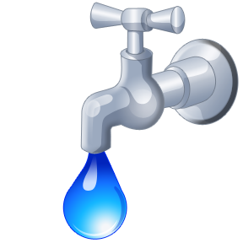 C:\Documents and Settings\jharding\Local Settings\Temporary Internet Files\Content.IE5\M5T1SDKR\MC900060285[1].wmf