You will need your Literature Book today!


Warm Up #5

“The Love of Money is the Root of all Evil”

- How important is the accumulation of money to you? Why? (Very – Somewhat – Not)
- What are people willing to do for money? Give examples of behavior motivated by greed.
- What would you do for money? What amount of money is enough to make you do something out of the ordinary?



Warm Up #7

FREE WRITE!!!



Warm Up #6

Do the Summoner and the Pardoner seem trustworthy?
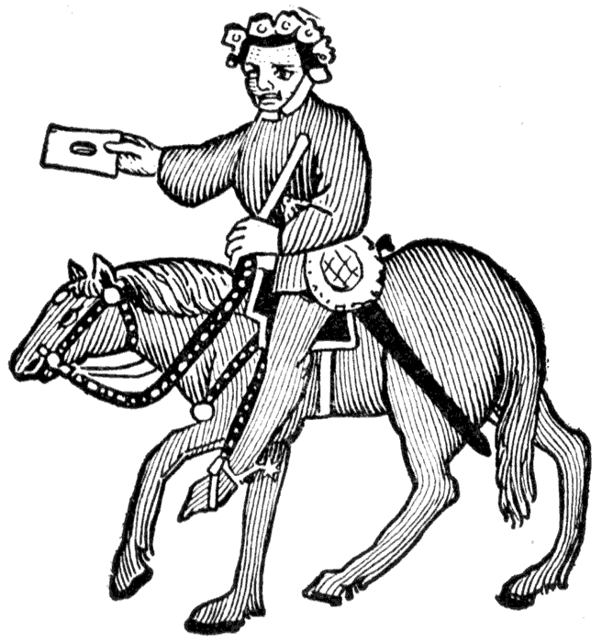 | 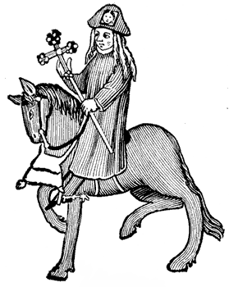
Explain your answer.

What point is Chaucer trying to make with his portrayal of these two clergymen?

Warm Up #8

Look back over “The Pardoner’s Prologue” pp. 96-97

Do you think the Pardoner is as bad as he admits or is he exaggerating in order to impress his audience?

Explain your reasoning with specific examples of what the Pardoner says in the prologue or the tale.

Warm Up #9

The three men start out hunting Death, but what do they find that (in the end) causes their deaths?
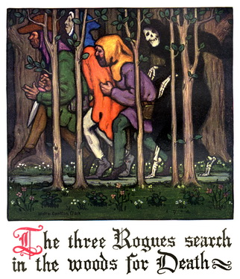
“There is no honor among thieves.”
What does this saying mean? How does it relate to the behavior of the three men?
Warm Up #10

Do you think the Pardoner’s story will encourage the pilgrims to buy indulgences?

Why or why not?
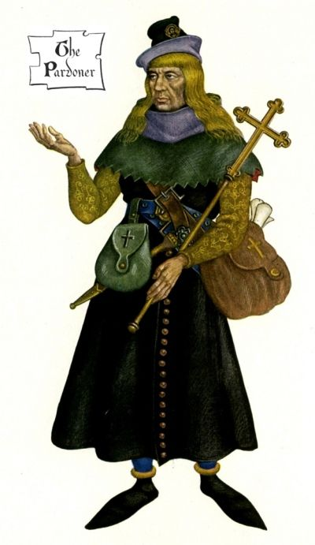

Warm Up #

FREE WRITE!!



You will need your Literature Book today!

Warm Up #1

What qualities or ideas come to mind when you think of the word “honor”?

With a partner, brainstorm ideas. Individually, design a flow chart using Lucidchart in Google Drive that explains people, things, or ideas that represent honor to you.


Google image search

- Create chart
- Save it (title “Honor”)
- Insert into Warm Up document

Warm Up #2

Predict: What will happen with the Green Knight?
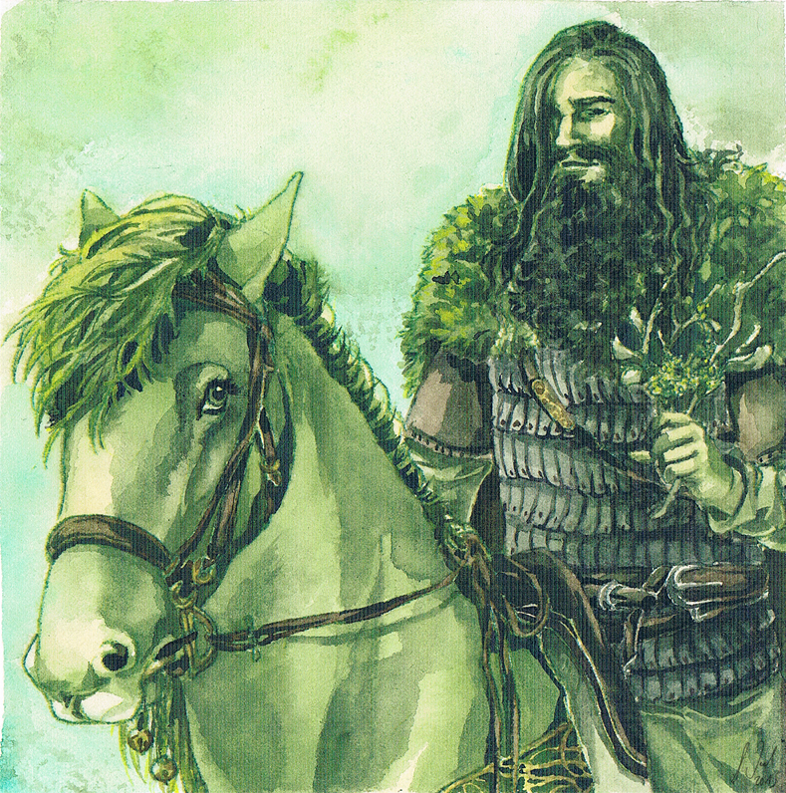
Remember, King Arthur and his men are celebrating Christmas.

Warm Up #

Briefly describe what happens to the Green Knight when Gawain strikes him with the axe using 3-5 of the vocab words below (underlined):

aghast heft ingeniously pivot reproof respite unwieldy flinch

Warm Up #3

Think about the way the Green Knight tests Gawain’s virtues at the castle.
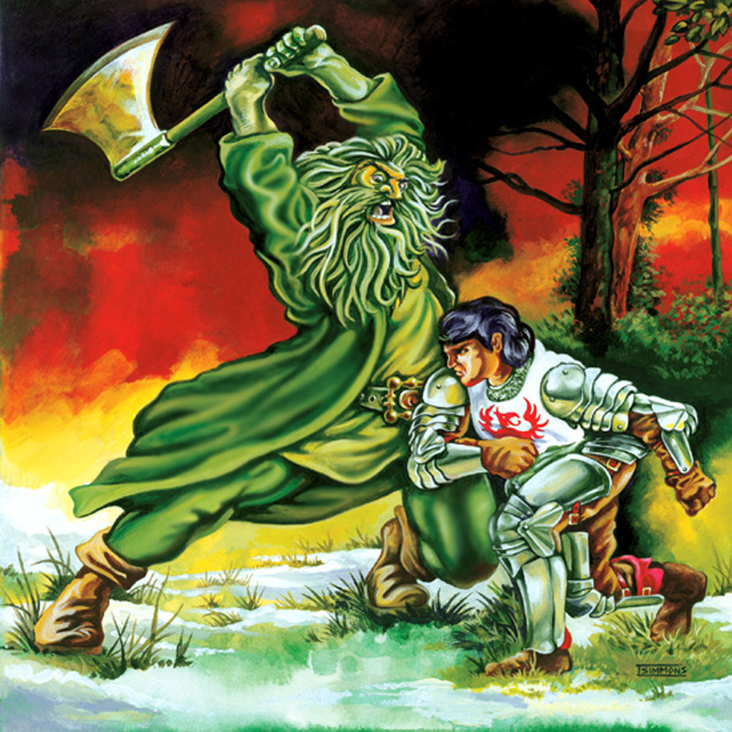
Do you think the test is fair? Why or why not?

Warm Up #4

If Arthur, Launcelot, and Gawain were given a second chance to resolve their conflicts, what do you think they might have done differently?

Explain your answer.

Warm Up #

Use 3-5 of the following vocabulary words to describe a scene or event from Le Morte d’Arthur.

usurp reeling depredation acquiesce assail

