Warm Up #1

- How do you define “great literature”?
- Read and paraphrase the following quote by C.S. Lewis.

In reading great literature, I become a thousand men and yet remain myself.

Warm Up #2

Beowulf is an ancient poem. Think about how many years have passed since the Old English poet began to write his heroic epic. (1300 yrs)
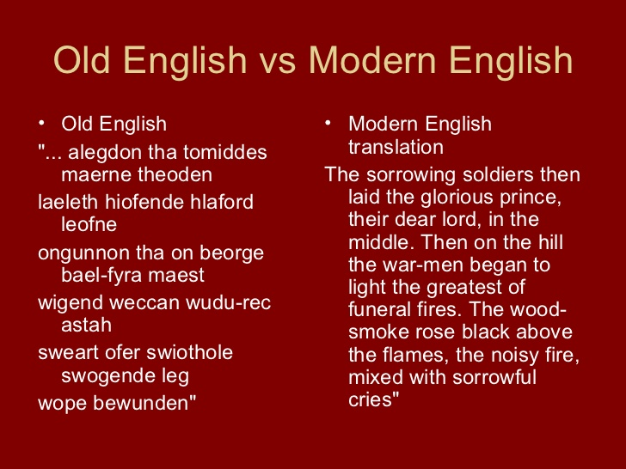
Can his eighth century words possibly stir the hearts, minds and spirits of twenty-first century readers?

Please explain your feelings as you prepare to read excerpts from Beowulf.

Warm Up #3

Think about the qualities of modern heroes and the enemies they battle.
What qualities, in your mind, make a hero? Please explain/elaborate.

Warm Up #4

Refer to line 58 on p. 28 in Beowulf. In what way has hate triumphed?

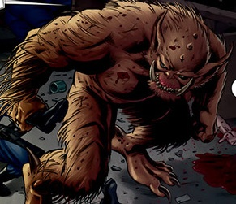

Prediction: What kind of person will try to stop Grendel from terrorizing Herot?

Warm Up #5

Possessive Apostrophe practice

Look at p. 36 in your book and identify the following nouns as singular possessive, plural possessive or plural.

- dragon’s in line 307
- Geats’ in line 319
- flames in line 324
- Edgetho’s in line 340

Now, please choose the correct form of the following sentences (please retype the sentences in your document):

- Beowulf fought three (monsters, monster’s, monsters’).
- The (Danes, Dane’s, Danes’) great hall was attacked.
- A (Danes, Dane’s, Danes’) head rolled.
- The field rang with (oxens, oxen’s, oxens’) cries.
Warm Up #6

Beowulf is able to defeat evil in the form of both Grendel and the dragon, yet he ultimately loses his life in the process.
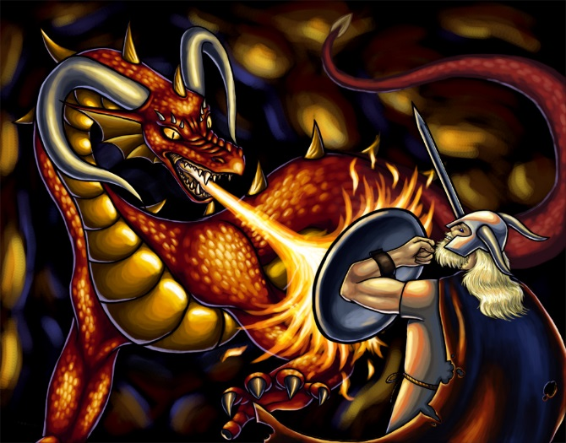
From this fact, what conclusions can you draw about the struggle between good and evil?

Warm Up #7

Alliteration is the repetition of consonant sounds at the beginning of words, as in the phrase “slowly setting sun”.
Alliteration can be used to emphasize particular words, heighten a mood, or create a musical effect.

With a partner, look back through Beowulf and find three examples of alliteration (include the line number).

Then, please explain what effect you feel the alliteration has on the poem?

Warm Up #8

Free Write!!

Journal #16

Considering the epic heroes we have covered in this unit – Beowulf and Achilles – who do you regard as a better epic hero?

Explain your reasoning by using examples from the epic poem characteristics chart.

